Name:- Mrunal Somankar

Roll No.:- TCOA46

Div:- A

Title:- Installation and configure Google app engine

Step 1:- Search Google Cloud Platform in a any search engine& Click on Console.

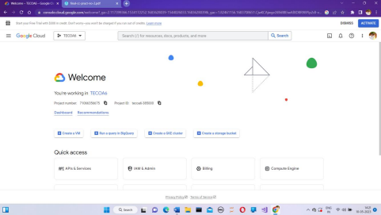

Step 2:- Click on select new project.

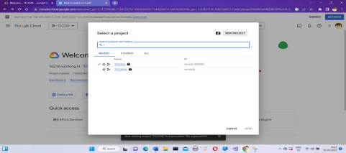

Step3:- Give Project name and click on create.

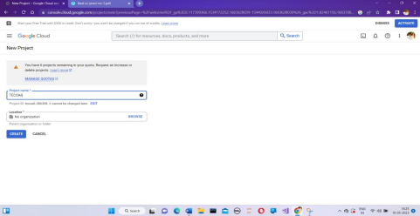

Step4:- Click on select project

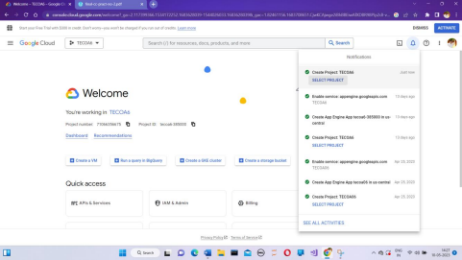

Step5:- In a search bar type search App Engine

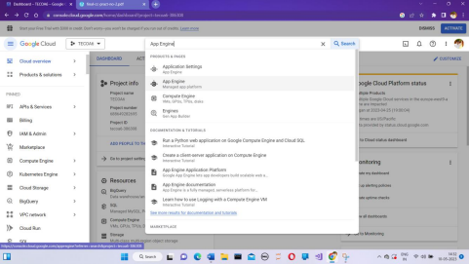

Step 6:-Click on App Engine and Following screen will appear& Click on Create Application.

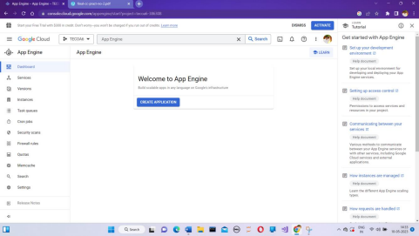

Step 7:- Click on next

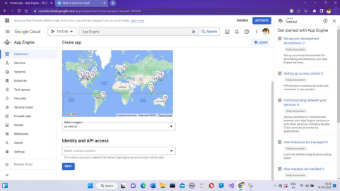Step 8:- Scroll down and click on l’ll do this later.

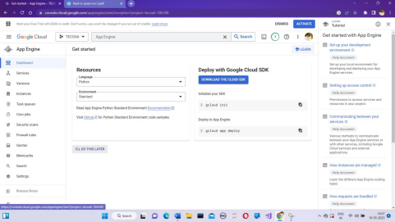

Sterp 9:- In search bar type App Engine Admin API.

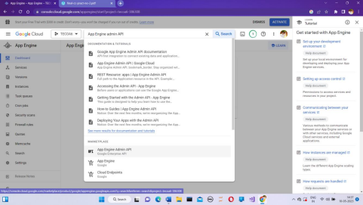Step 10:- Click Enables

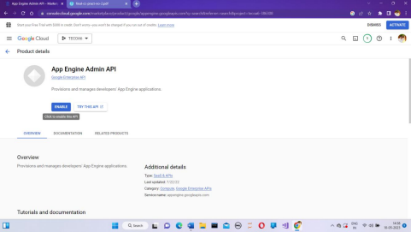

Step 11:- Click Activate Cloud Shell:-

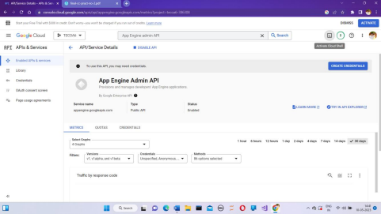Step 12 :- Following screen will appear:-

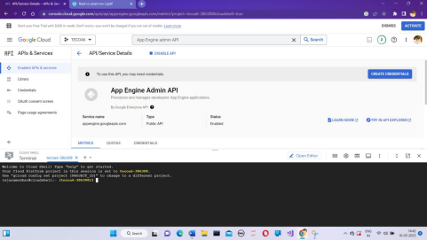

Step 13:- Login into your GitHub account and click on new repository. 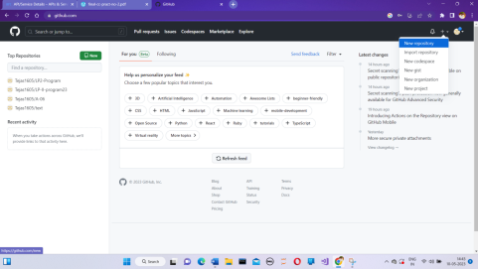Step 14 :- Give name to your repository and click create.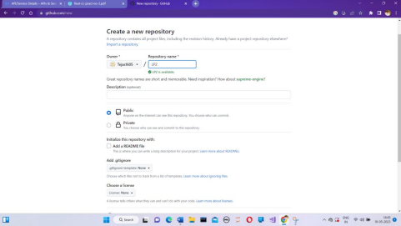

Step 15:- Click on creating new file

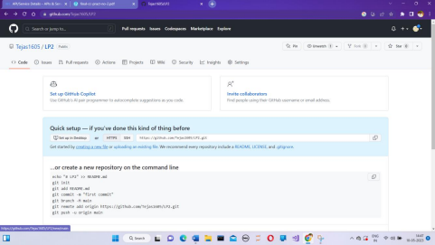Step 16 :- Give name to the python file & type your code.

Step 17:- Click on code and copy URL.

Step 18:- Go to cloud and type – git clone and paste url.

Step 19 :- Type ls

Step 20 :- Enter cd-repository name.

Step 21:- Type ls and to run python code type python-program name.